Some geography facts

Moving from north to south and clockwise direction.

# STATE MAPS

## MAP OF NORTH EAST

**CHINA**

Sikkim(gangtok) Arunachal(Guwahati/itanagar)(Namdhapa national park)

(Kanchendzonga national park)

Assam(guwahati) Nagaland(kohima) **MYANMAR**

(kaziranga,Manas,Dibru

Saikhova national park, Golden Langur endangered)

Meghalaya(shillong) Manipur(Imphal/guwahati)

(Kiebul Lamjao national park)

**BANGLADESH**

Tripura Mizoram(aizawl)

(agartala) **MYANMAR**

(**clouded leopard national park**)

**BANGLADESH BANGLADESH**

### Manipur

**Rivers** Barak and manipur river

**Keibul Lmjao National park(Manipur)**:

Only floating National park in world , Floating islands called as phumdis

Loktak lake phumdis.(**Ramsar site**)

Manipur Eld's deer or bow-antlered deer(E**ndangered**)

State animal: **Sangai or Bow-antlered deer(endangered)/sangai found in Loktak lake/sangai festival**

State bird : Mrs. Hume’s pheasant/ Nongin

Dance: **Manipuri or jagoi (A classical Indian dance) (Ras-lila)**

Language: Manipuri

Capital:Imphal

Demography: Meitei people

Gateway to East via Moerh and Tamu(Myanmar) towns

India Myanmar Thailand Trilateral highway project starts from **Moreh goes via Tamu towards Myanmar** and end at **Mai Sot in Thailand**

The India–Myanmar Friendship Road, forms part of the trilateral highway.

Polo originated from here

### Assam:

Kaziranga national park

Manas national park Both are Unesco world heritage sites

**Deepor Beel Ramsar Site**

Capital Dispur/Guwahati

All NE states have been made out of Assam, First being Nagaland last being AP and Mizoram

state bird: the white-winged wood duck

state animal: Indian Rhinoceros

Assamese and **bodo official languages**

Infra projects:

Dhola-sadiya bridge: India’s longest bridge 9.8 km

Between Dhola in Arunachal and Sadiya in Assam.

Digboi oil refinery

**National waterway 2(NW2)=Sadiya-Dhubri(near guwahati)(891km)**

Rivers:

Brahmaptra river is life line of assam an antecedent river

Barak river also in assam ,originate at Naga-assam border

Kaziranga: one horned rhinoceros

Also a tiger reserve🡪highest density of tigers

Ganges dolphin also found here (endangered)

Manas: also a tiger reserve

Also a elephant reserve

**22 of India’s most threatened species of mammals.**

**Golden Langur,pygmy hog(endemic)**

**Bengal florican(endangered)**

Economy:1/4 of oil reserves here and 50% of tea production

Asia’s first mechanical oil well was dug at assam

Digboi Asia’s first and world second oil refinery

Total 4 refineries are here

Guwahati,

History:

**Ahom kingdom in 1200AD, Sib singh,kingdom was divided into clan or khels,**

Festivals:

**BIHU-bihu dance,bodo dance**

Current affairs:

National citizens Register

### Arunachal Pradesh:

Orchid State of India

Capital Itanagar

India’s farthest eastern point Kibithu (28° N and 97° E)

Largest of the seven sister states of india

**Shimla accord: Tibet china and Britain draws Mc Mohan Line B/w India and outer Tibet**

Major rivers:

Subansiri

Dibang

Siang

Nao Dihang

Patkai Bum range

Namdhapa National park:

Namdapha National Park is the largest protected area in the Eastern Himalaya biodiversity hotspot

Third largest NP

Also a tiger reserve

Between Mishmi hills and Patkai hills

Divided by noa dihing river

Famous for flying squirrel,Red Panda

5 species of Horbills

Lisu tribal people live inside

**Mouling National Park**

Part of Dihang Dibang biosphere reserve

Mishmi takin rare species

**Asiatic black bear**

**Red Panda**

**Tawang buddhist monastery is largest in India and second Largest in World**

Demograhy Nishi man

Home to 30-50 distinct languages

State animal: Mithun

State bird: Hornbill

## MAP OF LAKSHDWEEP(KARAVATTI)

Kiltan Island

Kadmat(belongs to Amini)

Aminidivi N

Agatti W E

Karavatti **(c)** S

Suheli par **9 degree** Kalpeni

**channel**

(200 km between

Suheli par and kalpeni and maliku atoll in minicoy)

(All European trade goes through this channel)

Maliku Atoll

Minicoy

##### Eight degree channel

**Maldives**

State Animal: Butterfly fish

Economy : mostly dependent on export of Tuna fish

## ANDAMAN AND NICOBAR

North Andaman

Middle Andaman

South Andaman

Port Blair**(C)**

Little Andaman

**10 degree channel separates Andaman and nicobar**

Car nicobar

Little Nicobar

Great Nicobar

**(Great Nicobar national park**

Indira Point,Ins Baaz airforce station at campbell bay)

**6 degree channel**

**separates Nicobar and Indonesia in Andaman sea)**

Indonesia

State Animal: **Dugong (Red list-Vulnerable-water cow/herbivorous)**

Other (Nicobar long-tailed macaque(monkey))

State dance: Nicobari dance during Ossuary/pig festival

Bird: **Narcondom hornbill (endangered)**

## West Bengal

Capital : Kolkata🡪 Kolkata is known as **the "cultural capital of India"**

4th most populous state

Famous for Sundarbans

Darjeeling Hills

Ganga delta

History

Battle of Plassey in 1757: The British East India Company defeated Siraj ud-Daulah, the last independent Nawab,

British administration resulted in an expansion of Western education, culminating in developments in science, institutional education, and social reforms in the region, including what became **known as the Bengali Renaissance**

**the Brahmo Samaj socio-cultural reform movements**

Geography

Geographical indicator:

**Kaluchuri saree Rosgolla and 14 other things**

National park:

Sundarbans

South 24 parganas

delta of the Ganges, Brahmaputra and Meghna rivers

salt-tolerant mangrove forests due to special roots

Unesco site

Ramsar site

Royal Bengal tiger

River:

Ganga:

Tributary

Damodar, another **Right Bank tributary of the Ganges** and once known as the "**Sorrow of Bengal" ravaging floods in the plains of West Bengal**

**Damodar valley is called “the Ruhr of India”. for the generation of hydroelectric power.**

Tributary

Konar ,Left bank

Barakar(Left bank) biggest tributary, etc

It joins Hoogly river near Kolkata

Damodar Valley is home to three state-of-the-art steel manufacturing plants and they are Burnpur, Bokaro, and Durgapur

**Damodar is the most contaminated river in India**

Distributaries

Hoogly and bagirathi in Bengal(Right bank)

named Padma in Bangladesh

Farakka barrage on Ganga river

Rainfall:

Monsoon **thunderstorms known as Kalbaisakhi**

tree:

Sal tree predominant

State tree: Devil tree

State bird: white neck kingfisher

State animal: Fishing Cat

Economy:

West Bengal has the **fifth-highest GSDP** in India

Demographics

West Bengal is to indigenous tribal Adivasis such as

Santhal, Munda, Oraon, Bhumij, Lodha, Kol, and Toto tribe

**Lowest TFR in India**

Culture:

**Chhau dance**

**Abanindranath Tagore, called the father of modern Indian art, started the Bengal School of Art,**

Durga Puja is the biggest, most popular

## Odisha

capital : Bhubaneshwar

Also known as **Utkala in national anthem**

Balasore testing center for missiles

History:

Lower Paleolithic era tools

Kalinga kingdom

Shanti stupa by ashoka

Kharavela Kingdom:jain ruler ; hathigumpha at udayigiri hills

**Somavamsi dynasty 🡪Lingaraja temple**

**East ganga dynasty🡪Narsimhadeva 1 Konark sun temple**

**Ganga dynasty ruler Anantavarman build temple at puri for Vishnu**

**Balabhadra, Subhadra and jagannath image**

**Paṭṭacitra (meaning “cloth painting”) is a folk style of Odisha**

Geography

Utkal Plain is part of the East Coastal Plain of India;triple delta part of it including chilika lake

Rivers:

Subarnarekha

Rashikulya-olive ridley turtle(originate from Daringbadi, known as "**Kashmir of Odisha,")**

Betarini

Mahanadi Triple Delta rivers

Brahmini

**Chandipur famous for ebb tides**

Seasons:

Basanta (spring), Grishma (summer), Barsha (rainy season), Sharad (autumn), Hemant (winter), and Sisira(cool season)

National Parks

**Simplipal national park(tiger reserve)**

Giant squirrel

Malabar hornbill,

**Bhiterkanika**

Ramsar site

**Salt water crocodile**

Largest nesting site of olive ridley turtle, other include rashikulya

Endangered horse shoe crab found here

**second largest mangrove ecosystem**

Chilika lake:

Endangered Irrawadi dolphins found here

Chilika lake largest lake of India, Asia's largest brackish water lake

**Unesco world heritage**

Economy:

Bhubaneshwar first smart city in india

Raourkela steel plant

**1/3 of coal reserve,1/4 iron ore**

Demography:

3rd largest population of tribes in india

**Odiya is official language**

important tribes are Ho, Santhal, Bonda, Munda, Oraon, Kandha, Mahali and Kora

culture

Pahala rasgulla made in Odisha

Odissi classical dance form

The kitchen of the Shri Jagannath Temple, Puri is reputed to be the largest in the world

Mahanadi:

originate in chattisgarh

Hirakud Dam, which is the biggest earthfill dam in the world

Mahanadi River is regarded as the lifeline of Chhatisgarh

South to north

**Mahanadi🡪brahmani🡪baitarini**

## Andhra Pradesh

Capital: Amaravati

Indian Space Research Organisation (or Sriharikota Range (SHAR)) at barrier island of Sriharikota

History:

Vijaynagar empire

mural paintings

**Lepakshi Group of Monuments" among the UNESCO World Heritage sites in India**

**shrines dedicated to Shiva, Vishnu but also secular paintings here**

The last series of wall paintings in India are from Lepakshi,

Earth tones rather than blue color

**Machilipatnam style of kalamkari in blocks**

Amaravati;nagarjuni konda Mahayana Buddhism sites

First state to be formed on basis of language

Latest state of Telangana formed out of it

Geography:

Rivers:

Krishna; Godawari and Penner , tungabhadra

Pulicat lake🡪 second largest brackish water lake after chilika

Kolleru lake🡪 Ramsar site

Famous for Siberian crane

**Kolleru lake contains numerous fertile islets called lanka's,**

Demography:

Telegu language

Economy:

**"Rice Bowl of India"**

The most exported marine exports include Vannamei shrimp

KG basin Natural gas deposits

**Polavaram project to transfer from Godawari to Krishna rivers**

The state is a pioneer nationwide in solar power generation

Culture

**Kuchipudi classical dance**

**The Vijayanagara emperor Krishnadevaraya wrote Amuktamalyada.**

Machilipatnam and Srikalahasti kalamakari

**second longest caves named as Belum Caves.**

## Jammu and Kashmir

Capital: srinangar (S);Jammu(winter)

Only state with muslim majority

Himalyas divide j&K

**The Himalayas divide the Kashmir valley from Ladakh** while

the **Pir Panjal range, which encloses the valley from the west and the south, separates it from the Great Plains of northern India**

Geography

Pir panjal(Indrasar)

Himalayas

Hindu kush

Zanskar range(Tethys himalaya)

Ecology

State bird:

Black necked crain

State animal

Kashmiri stag/hangul critically endangered

Dachigam National Park

Dachigam literally means ‘ten villages’.

Near srinager

known for its fish population, the trout

Hangul(Kashmiri stag)🡪red deer🡪**critically endangered**

**Himalyan black bear**

Salim Ali national park

Kazinag national park

Kishtwar national park

**Hemis National park**

**In ladakh**

**Famous for snow leopard**s

**the largest notified protected area in India (and thus the largest national park of India)**

only park north of Himalayas

is the second largest contiguous protected area, after the Nanda Devi Biosphere Reserve

**Hemis National Park is India's only protected area inside the Palearctic ecozone,**

Indus river flows at north west boundary

the golden eagle

Ramsar sites:

The Ramsar Convention is the only global environmental treaty that deals with a particular ecosystem. The treaty was adopted in the Iranian city of Ramsar in 1971

**Tso moriri**

**one of the most endangered cranes, the Black-necked crane (Grus nigricollis), and**

the only breeding ground for Bar-headed geese in India

**Surinsar-mansar**

Economy

**The Kashmir Valley is known for its sericulture and cold-water fisheries.**

Wood from Kashmir is used to make high-quality cricket bats, popularly known as Kashmir Willow.

Kashmiri saffron is very famous and brings the state a handsome amount of foreign exchange

Horticulture plays a vital role in the economic development of the state

Gulmarg, one of the most popular ski resort destinations in India, is also home to the world's highest green golf course.

Culture

Ladakh is famous for its unique Indo-Tibetan culture.

**Chanting in Sanskrit and Tibetan language forms an integral part of Ladakh's Buddhist lifestyle.**

The Dumhal is a famous dance in the Kashmir Valley, performed by men

Women perform Rauf

## Nilgiri hills

Located in southern India where the **states of Tamil Nadu, Kerala and Karnataka all come together and rise to a height of 2,400 meters**.

The highlands are rolling grasslands with patches of temperate forest known as **shoala**

Asian elephants, tigers, leopards, wild dogs, chital, sambar, barking deer, mouse deer, wild boar, **bonnet macaques**, common langurs, giant squirrels, flying squirrels, monitor lizards, pythons, crocodiles, **Malabar trogons, Malabar grey hornbills, great black woodpeckers, crested hawk eagles, crested serpent eagles**, common scops owls, little scops owls, tiny eared owls, parakeets, cuckoo and lots of butterflie

# Maps Waterways

Waterways are developed by the central government through **the Inland Waterways Authority of India (IWAI)** - the regulatory body for the Inland Waterways Transport (IWT) sector

The National Waterways Act, 2016, 111 waterways have been declared as National Waterways (NWs) including the five existing NWs. Out of the 111 NWs, NW-1, 2, & 3 are already operational.

## Jal Marg Vikas project

On NW1

Intermodal Terminal on National Waterways –I (River Ganga) at Ghazipur

## National Waterway 1:

Ganga-Bhagirathi-Hooghly river

Haldia (Sagar) to Allahabad.

The NW-1 passes through **West Bengal, Jharkhand, Bihar and Uttar Pradesh**.

Farakka port present on this

1620km

## National Waterway 2:

**Dhubri(Assam) to sadiya(Arunachal)**

891 km

## National Waterway 3:

168km

**Also known as West coast canal**

**Kollam to kottapuram both in KERELA**

**It is the first National Waterway in the country with 24-hour navigation facilities along the entire stretch**

Extended to KHozikhode

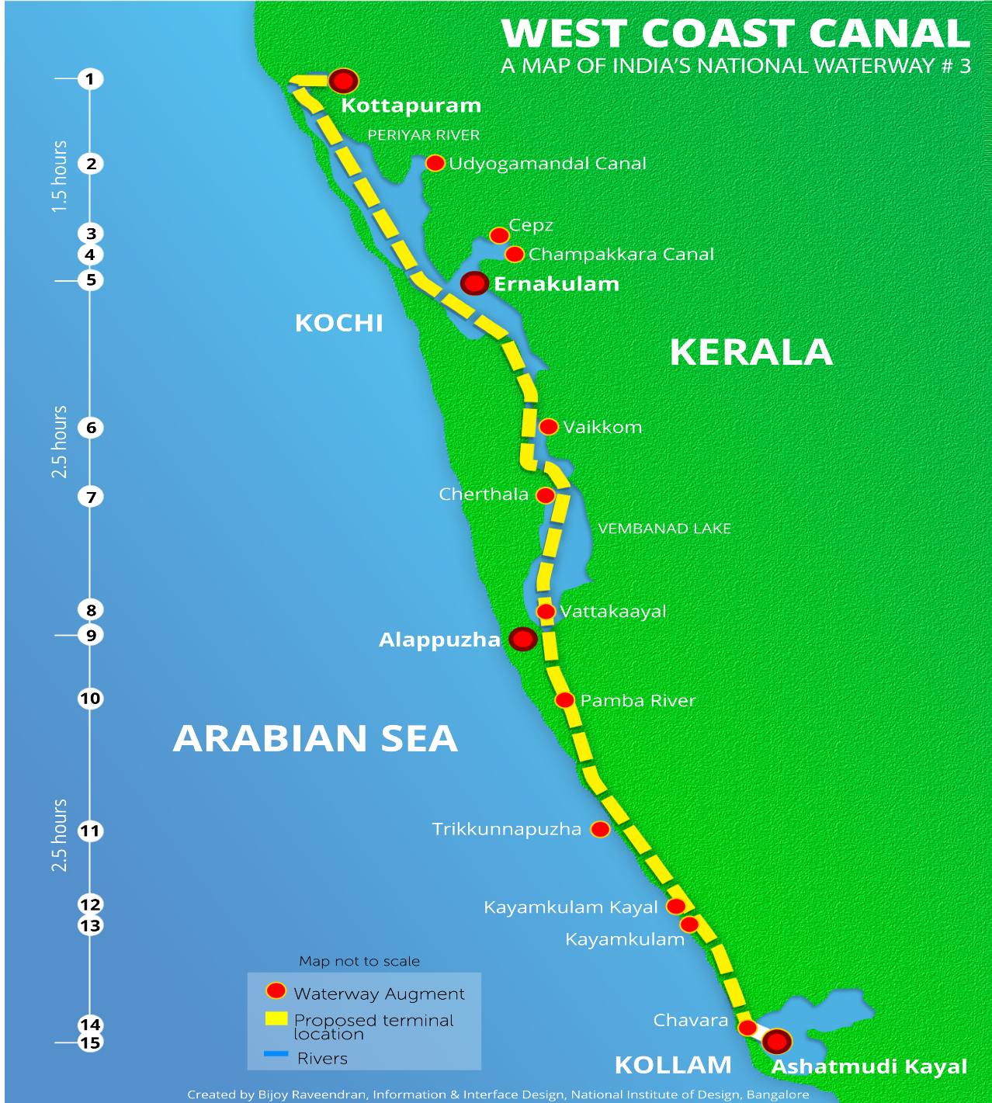

## National Water way 4:

1095km

Proposed 2890

**Includes Buckingham canal**

From Puducherry(TN) to Telangana

**On Coromandal coast**

connects the Indian states of Telangana,Andhra Pradesh, Tamil Nadu, and the union territory of Puducherry

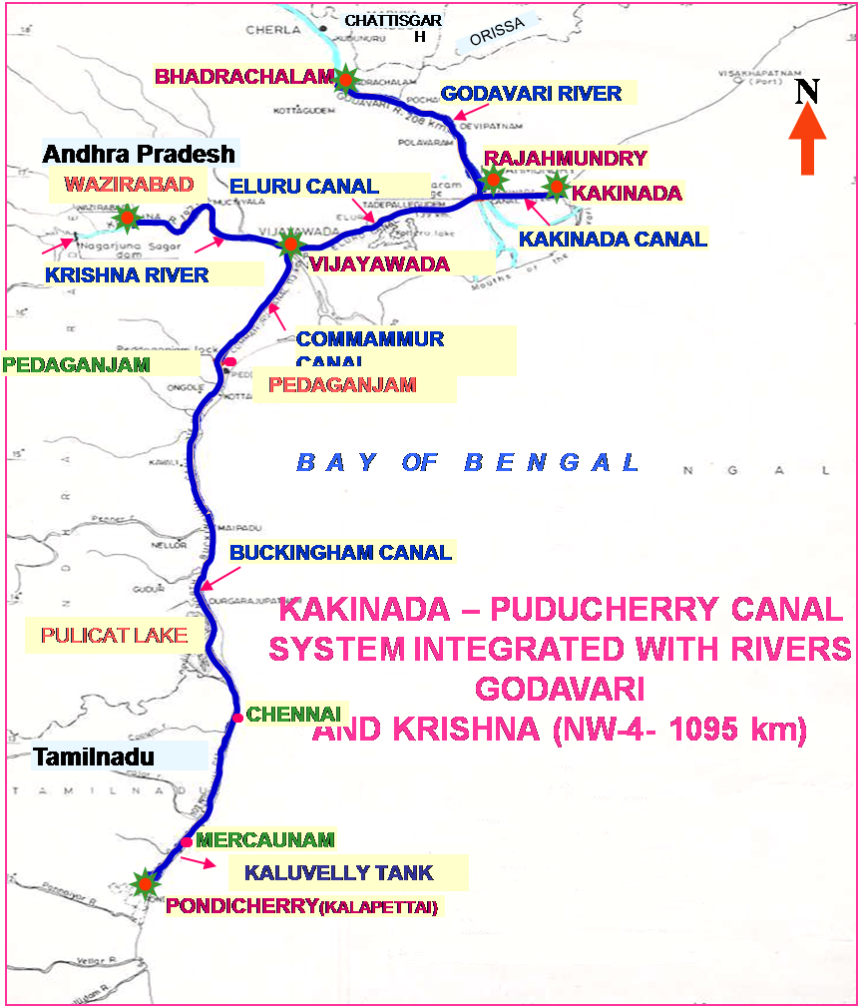

## National waterway 5

588km

**Odisha and west benagal**

**Triple delta included**

**Paradeep in Odisha to geokhali in WB**

**To include East coast canal**

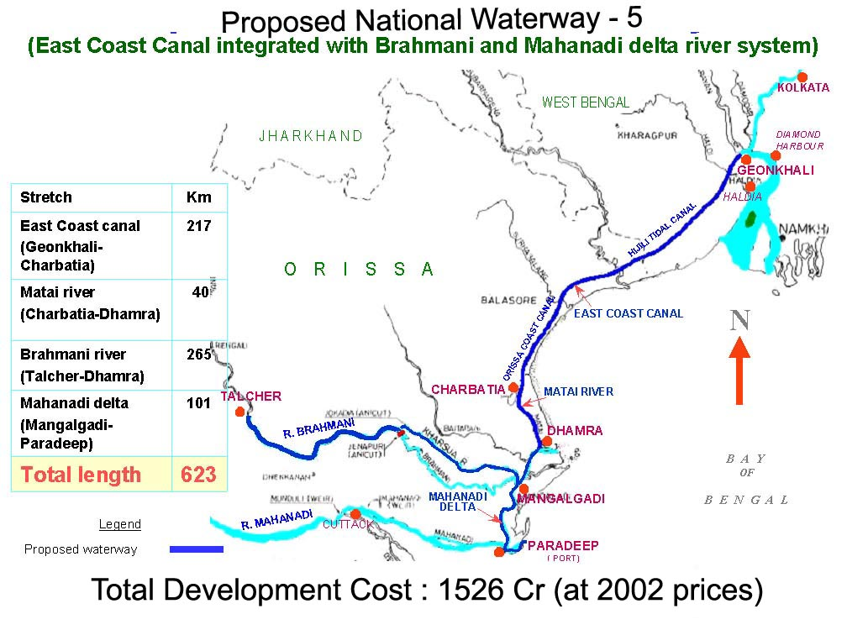

# Tunnels and bridges

## Zojila tunnel:

**On Zojila pass Srinagar-Kargil-Leh**

**In J&K**

**Connects Ladakh to Kashmir valley**

**Will be Asia’s longest bi-directional tunnel, 14km**

The project will be implemented by the Ministry of Road Transport & Highways through the National Highways and Infrastructure Development Corporation Limited (NHIDCL),

## Chenani Nashri Tunnel

In J&K

**Himalayan range at an altitude of 1,200 metres**

**Longest tunnel till date**

Jammu and Srinagar is reduced by 30 km and travel time is cut by two hours

**he tunnel is the country’s first — and the world’s sixth — road tunnel with a transverse ventilation system**

Also known as **Patnitop Tunnel**

## Se la pass tunnel

To be constructed in Arunachal

North east frontier

Tawang area in AP

13,700 feet Sela Pass that falls between the northeastern state’s West Kameng and Tawang districts

from Bomdila to Tawang remains open throughout the year in all weather conditions

Implemented by BRO’s under Project Vartak(est. in 1963)

## SASEC

**South Asia Subregional Economic Cooperation** (**SASEC**) Program, set up in 2001, brings together Bangladesh, Bhutan, India, Maldives, Myanmar, Nepal, and Sri Lanka in a project-based partnership to promote regional prosperity by improving cross-border connectivity, boosting trade among member countries,

## Dhola Sadiya Bridge

**India’s longest river bridge**

Also known as  **Bhupen Hazarika Setu**

**In Assam over built across the Lohit river, which is a tributary of the Brahmaputra**

Dhola and sadiya both in assam

The bridge will reduce the travel time between Assam and Arunachal Pradesh from six hours to just one hour as the distance will shrink by 165 km

It is 3.55 km longer than the **Bandra-Worli sea link in Mumbai(a bridge over Mahim Bay**). The sea link has now become the second longest river bridge in the country.

Third will be **now Mahatma ganghi setu** in Bihar over Ganga in Patna-Hajipur

State-run SAIL is the largest supplier of steel for the bridge. The PSU has supplied around 90% or around 30,000 tonnes of steel,

# Dams

## Sardar sarovar dam

It is the second-biggest concrete gravity dam in the world after the Grand Coulee Dam in the United States

canal network will also irrigate parts of Rajasthan, Maharashtra and Madhya Pradesh.

Over Narmada river in Gujrat

# Corridors

## East West Corridor

**NH 27 starts at Porbandar in Gujrat to terminates in Silchar in Assam**

East west highways are odd numbered and numbers increase towards west

the states of Gujarat, Rajasthan, Madhya Pradesh, Uttar Pradesh, Bihar, West Bengal, Assam.

**National Highway 47A, which starts from NH 47 at Kundannur, is the shortest highway in India.**

**It has a length of 6 Kilometeres in total.**

It links the man-made isle of Willingdon Island with Kochi bye-pass

## North south corridor:

North south highways are even numbered and number increase towards south

**NH 44**

**National Highway 44 (NH 44) is the longest-running major north–south National Highway in India.**

**It starts from Srinagar and terminates in Kanyakumari;**

the highway passes through the states of Jammu & Kashmir, Punjab, Haryana, Delhi, Uttar Pradesh, Madhya Pradesh, Maharashtra, Telangana, Andhra Pradesh, Karnataka, and Tamil Nadu

# Latitudes and Longitudes

## Latitudes

### Tropic of Cancer

At 23.5 degree North

Passes in India.

1. Gandhinagar (Gujrat) - 23.10 N
2. Jaipur (Rajasthan) - 26.55 N
3. Bhopal (M.P) - 23.16 N
4. Raipur (Chattisgarh) - 21.16 N
5. Ranchi (Jharkhand) - 23.11 N
6. Kolkata (W.B) - 22.34 N
7. Agartala (Tripura) - 23.51 N
8. Aizwal (Mizoram) - 23.36 N

# Ramsar Sites

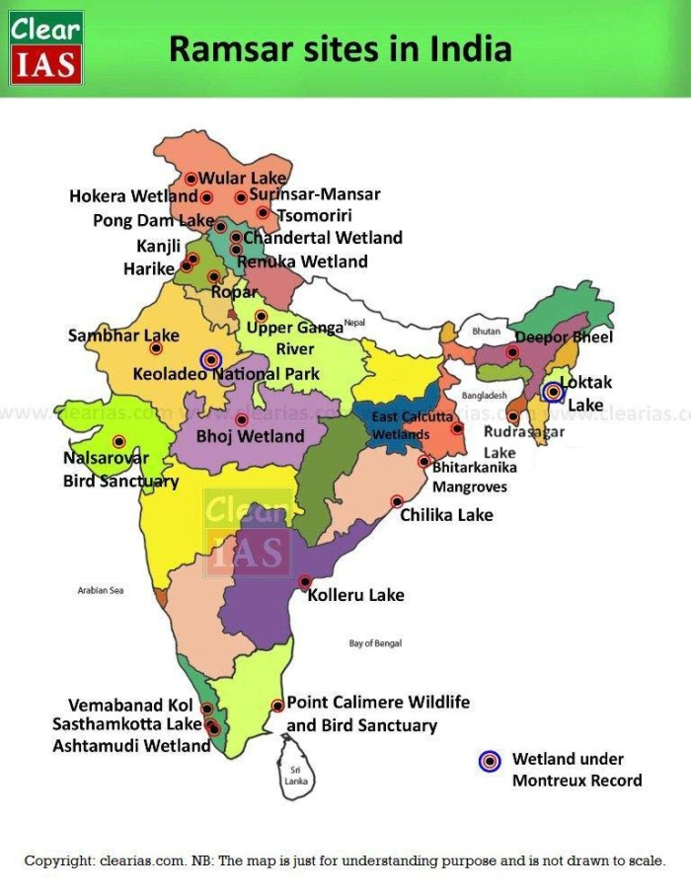

# Sea

**Black sea**

Ukraine Russia

Romania

Bulgaria Georgia

Turkey

**Caspian sea**

Russia

kazakhstan

Azerbaijan

Turkmenistan

Iran;

**Red sea**

Egypt Saudi arabia

Eritrea

yemen

djibouti

###### Dead sea

The Dead Sea – bordering Israel, the West Bank and Jordan – is a salt lake whose banks are more than 400m below sea level, the lowest point on dry land. Its famously hypersaline water makes floating easy

Israel Jordan

**Sea of Marmara**

**Turkey**

**Turkey**

**Sea of azov**

**Russia**

**Ukraine**

**Cremian peninsula**

**Black sea**

**North sea**

**Norway**

**Denmark**

**Germany**

**Netherlands**

**UK Belgiam**

**Baltic sea**

**Sweden finland/**

**Russia**

**Denmark**

**Germany poland**

Kara sea

Arctic ocean

Russia

Bering sea

Russia Alaska(USA)

**Arafura sea**

**Tasman sea**

**Java sea**

**Lacadive sea**

###### Mediterranean sea

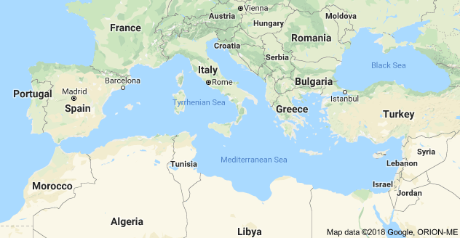

# Rivers

Cauvery

Dakshin ganga

receives rainfall during summer by the south-west monsoon and the lower catchment area during winter season by the retreating north-east monsoon.

Most regulated river of india about 95% used for irrigation and electricity production

***Sivasamudram waterfalls (101 m high).***

**Salem steel plant** and many engineering industies in Coimbatore and Trichinapally are also situated in this basin.

Tributeries

* Left Bank: the **Harangi**, the **Hemavati**, the **Shimsha** and the **Arkavati**.
* Right Bank: **Lakshmantirtha**, the **Kabbani**, the **Suvarnavati**, the **Bhavani**, the **Noyil**and the **Amaravati** joins from right.
  + **‘Akhanda Cauvery’. After amarvati and noyil joins it**

Distributary

At grand anaicut made by chola kings

It is **divided into 2 cauvery to left and Vennar to right**

Origin of rivers

|  |  |
| --- | --- |
| Ganga | Gangotri (Uttarakhand) |
| Yamuna | Yamunotri (Uttarakhand) |
| Indus | Mansarovar (Tibet) |
| Narmada | **Maikal Hills**, Amarkantak (MP) |
| Tapi/Tapti | **Satpura Range**, Betul (MP) |
| Son | **Maikal hills,Amarkantak(MP)** |
| Mahanadi | Nagri Town (Chhattisgarh) |
| Brahmaputra | Chemayungdung (Tibet) |
| Sutlej | Mt Kailash (Tibet) |
| Beas | Rohtang Pass (Himachal Pradesh) |
| **Godavari** | **Nasik (Maharashtra)** |
| **Krishna** | **Mahabaleshwar (Maharashtra)** |
| **Cauvery** | **Brahmagiri Hills, Coorg (Karnataka)** |
| **Sabarmati** | **Udaipur, Aravalli Hills (Rajasthan)** |
| Ravi | Chamba (Himachal Pradesh) |
| Pennar | Nandi Hills, Chickballapur (Karnataka) |
| Luni | Pushkar, Aravalli Hills (Rajasthan) |
| **Chambal** | **Janapav, Indore, Vindhyas (MP)** |
| Teesta | Cholamu Lake (Sikkim) |
| Rangeet | Rathong Glacier (Sikkim) |

Confluence of rivers

|  |  |
| --- | --- |
| Alaknanda and Dhauliganga | Vishnuprayag (Uttarakhand) |
| Alaknanda and Nandakini | Nandaprayag (Uttarakhand) |
| Alaknanda and Pindar | Karnaprayag (Uttarakhand) |
| Alaknanda and Mandikini | Rudraprayag (Uttarakhand) |
| Alaknanda and Bhagirathi | Devprayag (Uttarakhand) |
| **Ganges and Yamuna** | **Allahabad (Uttar Pradesh)** |
| **Yamuna, Chambal, Pahuj, Sind and Kuwari** | **Pachanada (Etawah dist of UP)** |
| Ganges and Kosi | Kurusela (Katihar dist of Bihar) |
| Yamuna and Betwa | Hamirpur (Uttar Pradesh) |
| Krishna and Tungabhadra | Alampur (Mahbubnagar dist of Telangana) |
| Godavari and Indravati | Bhadrakali (Bijapur dist of Chhattisgarh) |
| Godawari and Prenhita | **Kaleshwaram(also a hydro project)** |
| Kishna and godawari | Koleru lake or wetland |
| Tunga and Bhadra | Koodli (Shimoga dist of Karnataka) |
| Ganges and Gandak | Hajipur (Bihar) |
| **Sutlej and Beas** | **Harike Wetland (Punjab)** |
| **Subarnarekha and Kharkai** | **Jamshedpur (Jharkhand)** |
| **Gambira and Banganga rivers.** | **Keladeo national park(wetland)** |

The **Nile**

is one of the world's great waterways, at 4,180 miles (6,695 kilometers) generally regarded as the longest river in the world in Africa

Originates from lake Victoria

the Blue Nile starts at Lake Tana in [Ethiopia](http://www.newworldencyclopedia.org/entry/Ethiopia) and flows into Sudan from the southeast.

**The two rivers meet near the Sudanese capital,**[**Khartoum**](http://www.newworldencyclopedia.org/entry/Khartoum)**.**

The White Nile rises in the Great Lakes region of central [Africa](http://www.newworldencyclopedia.org/entry/Africa), with the most distant source in southern [Rwanda](http://www.newworldencyclopedia.org/entry/Rwanda), and flows north from there through [Tanzania](http://www.newworldencyclopedia.org/entry/Tanzania), [Lake Victoria](http://www.newworldencyclopedia.org/entry/Lake_Victoria), [Uganda](http://www.newworldencyclopedia.org/entry/Uganda), and **southern**[**Sudan**](http://www.newworldencyclopedia.org/entry/Sudan)

**The Great Bend is one of the most unexpected features of the Nile.** For most of its course, the Nile flows inexorably north, but in the heart of the [Sahara Desert](http://www.newworldencyclopedia.org/entry/Sahara_Desert), it turns southwest and flows away from the sea for 300 kilometers before resuming its northward journey. This deflection of the river's course is due to tectonic uplift of the Nubian Swell. This uplift is also responsible for the cataracts

**Amazon River**,

**the largest**[**drainage**](https://www.britannica.com/topic/drainage) **system in the world in terms of the volume of its flow and the area of its**[**basin**](https://www.britannica.com/science/drainage-basin)

The Amazon River of [South America](http://www.newworldencyclopedia.org/entry/South_America) is the world's largest [river](http://www.newworldencyclopedia.org/entry/River) and the lifeblood of the world's largest [ecosystem](http://www.newworldencyclopedia.org/entry/Ecosystem),

It is the mightiest river in the world by volume,

Because of its vast dimensions it is sometimes **called *The River Sea***

Starts from andes and drains into atlantic ocean

Originates in Peru high in Andes mountains

The Tidal bore is the reason the Amazon does not have a river delta; the ocean rapidly carries away the vast volume of silt carried by the Amazon, making it impossible for a delta to grow

**Amazonian Rainforest**

From the east of the [Andes Mountains](http://www.newworldencyclopedia.org/entry/Andes_Mountains), the vast Amazon Rainforest begins.

It is the largest [rain forest](http://www.newworldencyclopedia.org/entry/Rain_forest) in the world and is of great ecological significance, as its biomass is capable of absorbing enormous amounts of [carbon dioxide](http://www.newworldencyclopedia.org/entry/Carbon_dioxide).

the river is one of the main habitats of the **Boto, also known as the Amazon River**[**Dolphin**](http://www.newworldencyclopedia.org/entry/Dolphin). The largest species of river dolphin

Manaus, the largest city on the Amazon

European rivers

**DANUBE: Beginning in the Black Forest region of Germany**, it flows across central Europe and the countries of Austria, Hungary, Croatia and Yugoslavia.

It then forms the border between Romania and Bulgaria, turning north across Romania to eventually **end in the Black Sea.**

It is (1,771 miles) (2,850 km) in length, and one of the most significant commercial waterways on the continent.

**Main-Danube waterway connecting the Rhine with the Black Sea**

**VOLGA:** The Volga is the largest river in European Russia in terms of length, discharge, and watershed.

It flows through central Russia, and is widely viewed as **the national river of Russia**. It's 3,692 km (2,294 mi) long

**RHINE: Forming in the mountains of southeastern Switzerland**, this legendary river flows west, forming Switzerland's northeastern border with Germany, then runs directly north through **western Germany forming part of that country's border with France**, then finally dissecting the Netherlands and ending in the North Sea.

**The busiest shipping route in the world**

**Numerous tributaries and branches run in all directions, and in overall length is (820 miles) (1,319 km).**

**DNIEPER:**Rising in the southwestern part of the Russian Federation, it flows generally south through Belarus, then southeast through Ukraine, ending in the Black Sea. Overall it's (1,420 miles) (2,285 km) in length.

**DON:**Beginning it the southwestern Russian Federation, to the south of Moscow,

it flows southeasterly towards the Volga, then turns abruptly west, ending in the Sea of Azov. Overall it's (1,224 miles) (1,969 km) in length.

**ELBE:**Rising in the Czech Republic, the Elbe River then flows north through Germany, ending in the North Sea near Cuxhaven. It's (724 miles) (1,165 km) in length.

**LOIRE:** **Recognized as the longest river in France,** the navigable Loire begins in the foothills of the Massif Central, then flows north and west across the heartland of France, finally ending in the Bay of Biscay. It's (634 miles) (1,020 km) in length.

**ODER:**Rising in the rugged mountains of the eastern Czech Republic, it flows west and north through south-central Poland, eventually emptying into the Baltic Sea. It's (567 miles) (912 km) in length.

**PO: Italy's longest river begins in the upper reaches** of the Alps, flowing west to east across northern Italy, ending in the Adriatic Sea. It's (405 miles) (652 km) in length.

**RHONE:**Begin high in the Swiss Alps, this fast moving river flows into the eastern end of Lake Geneva, then south through south-eastern France, emptying into the Mediterranean Sea.

Small branches run in all directions, and in overall length, it's (300 miles) (485 km).

**SHANNON:**Rising in northwestern Ireland, it flows south through a series of lakes, then turns west to eventually empty into the Atlantic Ocean. It's 230 miles (370 km) in length.

**TAGUS: The Tagus River rises in the central highlands of Spain**, flowing southwest across Portugal, then south to Lisbon and the Atlantic Ocean. It's 626 miles (1,007 km) in length.

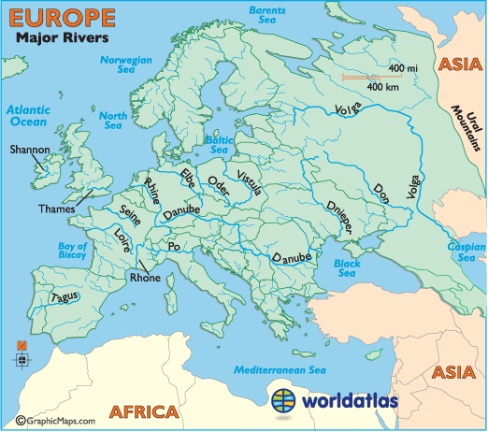

# Great Lakes

Lake Baikal

it also the world’s largest lake by volume, and

the world’s deepest lake.

It may even be one of **the oldest lakes on our planet**,.

Freshwater

It is called the “Galapagos of [Russia](https://www.worldatlas.com/webimage/countrys/europe/ru.htm) owing to the isolation from humans and longstanding age

Caspian Sea

Largest saltwater lake

The Caspian Sea has [Iran](https://www.worldatlas.com/webimage/countrys/asia/ir.htm), [Kazakhstan](https://www.worldatlas.com/webimage/countrys/asia/kz.htm), [Turkmenistan](https://www.worldatlas.com/webimage/countrys/asia/tm.htm), Russia and [Azerbaijan](https://www.worldatlas.com/webimage/countrys/europe/az.htm) among its basin countries.

The Volga, Ural, Terek, and Kura Rivers all serve as major sources of inflow feeding the Caspian Sea.

Great lakes America

The Great Lakes began to form at the end of the last glacial period around 14,000 years ago,

SMHOE🡪north south order

SMHEO🡪west-east order

Lake Michigan

It’s the largest amongst all of the lakes that are found entirely within one single country.

Saint Lawrence waterway here

**St. Lawrence River system has become one of the world’s most heavily used**[**international trade**](https://www.britannica.com/topic/international-trade)**routes**

Lake Huron

world’s 4th largest lake, and the 3rd largest fresh water

Lake Superior

Lake Superior is the 2nd largest freshwater lake in the world by volume

10 percent of all the world's fresh surface water.

Some of the world's oldest rocks can be found on its shore

Lake Errie

Lake Ontario

African Great Lakes:

* [Lake Victoria](http://www.newworldencyclopedia.org/entry/Lake_Victoria) (68,800 square kilometers; elevation 1,133 meters) is the continent's **largest lake, the largest tropical lake in the world,** and **the second largest freshwater lake in the world in terms of surface area. After lake Baikal**
* [Lake Tanganyika](http://www.newworldencyclopedia.org/entry/Lake_Tanganyika) (32,000 square kilometers; elevation 773 meters) **is the largest and deepest of the Rift Valley lakes** and is thought to be the **second-oldest lake on the planet (after**[**Lake Baikal**](http://www.newworldencyclopedia.org/entry/Lake_Baikal)**)**; part of the [Congo River](http://www.newworldencyclopedia.org/entry/Congo_River) basin, it feeds into it via the Lukuga River
  + - Longest lake in world

Freshwater

* **Lake Malawi** (29,600 square kilometers; elevation ) **is the most southerly lake in the Great African Rift Valley system, the third largest lake in**[**Africa**](http://www.newworldencyclopedia.org/entry/Africa)**,** and the ninth largest in the world
  + - Lake Malawi is drained by the Shire River into the [Zambezi](http://www.newworldencyclopedia.org/entry/Zambezi)
* **Lake Turkana** (6,405 square kilometers; elevation 360 meters) **is the world's largest permanent desert lake and the world's largest alkaline lake.**
  + - **By volume it is the world's fourth largest salt lake.**
    - **. Lake Turkana has no outlet**
* Lake Albert (5,300 square kilometers; elevation 615 meters) is the **northernmost lake in the Western Rift**
* Lake Edward (2,325 square kilometers; elevation 912 meters) **drains north into Lake Albert**
* Lake Kivu 2,220 square kilometers; elevation 1,460 meters) **empties into Lake Tanganyika** via the Ruzizi River

**Lake Victoria, Lake Albert, and Lake Edward** are the only three that empty into the White Nile, which feeds into the [Nile River](http://www.newworldencyclopedia.org/entry/Nile_River)

Lake Tanganyika and Lake Kivu both empty into the [Congo River](http://www.newworldencyclopedia.org/entry/Congo_River) system

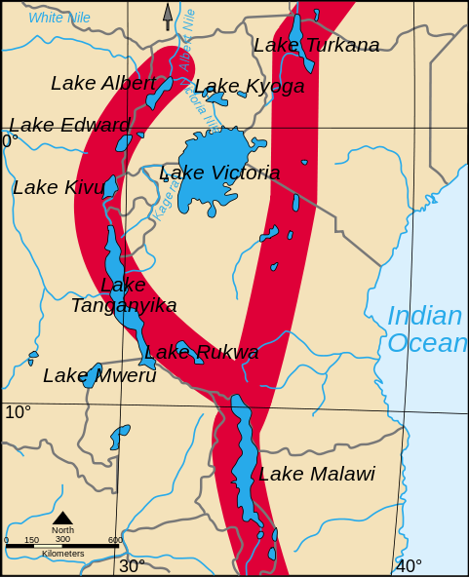

# Geology

## Rocks

### Igneous rocks

Igneous rock is formed through the cooling and solidification of magma or lava.

Intrusive or Plutonic: formed by magma cooled slowly inside earths crust

Extrusive or Volcanic: formed by fast cooling of lava on surface of earth

Example Basalt; gabbro; granite

Granite Basalt

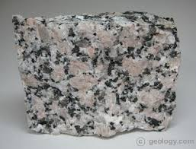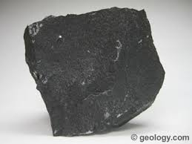

### Sedimentary rocks

Formed by weathering of old rocks;

Also known as secondary rocks

Weathering can be chemical, mechanical

When weathered sediment(rock, mineral or organic material ) over a period of time accumulates

Limestone; sandstone; dolstone ; coal; shale

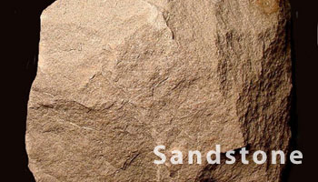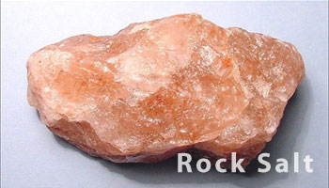

### Metamorphic rocks

Metamorphic rocks are formed by subjecting any rock type—sedimentary rock, igneous rock or another older metamorphic rock—to different temperature and pressure conditions

Can also be called secondary rocks as they are formed by metamorphism of original rock

**Method is called as Metamorphism.**

**Metamorphic rocks are not made from melting rock. (Rocks that do melt form igneous rocks instead**

**The original rock, known as the protolith, transforms into other mineral types or other forms of the same minerals, by recrystallization.**

Non foliated: formed when pressure is low; marble,slate

Foilated: formed under high pressure ; gneiss

Schists; quartzite; marble; soapstone (from where talc is obtained)

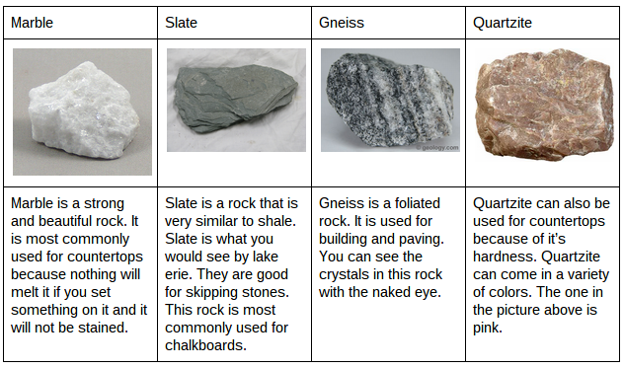

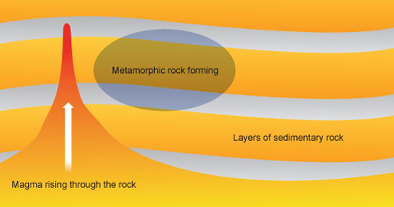

## Soils

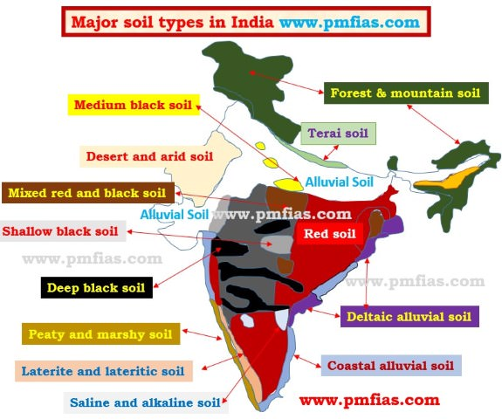

# Oceanography

## Upwelling:

process in which cold, nutrient-rich water from the bottom of an ocean basin or lake is brought to the surface due to atmospheric effects such as the Coriolis force or wind.

Coastal **upwelling**occurs where Ekman transport moves surface waters away from the coast; surface waters are replaced by water that wells up from below.

Leads to colder waters on coastlines

**Surface winds leads to upwelling and downwellung**

In the Northern Hemisphere,

upwelling occurs **along west coasts** (e.g., coasts of California, Northwest Africa) **when winds blow from the north (causing Ekman transport of surface water away from the shore)**.

Winds blowing from the south cause upwelling along continents' eastern coasts in the Northern Hemisphere,

***Wind direction important for helping to locate upwelling around continent***

In southern Hemisphere

Upwelling also occurs along the west coasts in the Southern Hemisphere (e.g., coasts of Chile, Peru, and southwest Africa) when the wind direction is from the south because the net transport of surface water is westward away from the shoreline.

Winds blowing from the north cause upwelling along the continents' eastern coasts in the Southern Hemisphere.

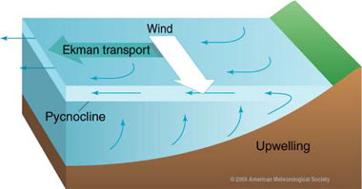

## Downwelling:

Where Ekman transport moves surface waters toward the coast, the water piles up and sinks in the process known as coastal **downwelling**.

Leads to warmer water on coast lines

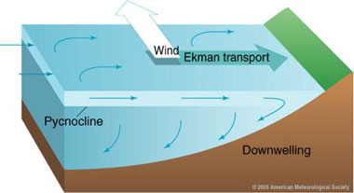

## Some effects of upwelling and down welling

**Coastal upwelling and downwelling also influence weather and climate**.

Along the northern and central California coast, **upwelling lowers sea surface temperatures** and **increases the frequency of summer fogs.**

Relatively cold surface waters chill the overlying humid marine air to saturation so that thick fog develops.

**Upwelling cold water inhibits formation of tropical cyclones (e.g., hurricanes), because tropical cyclones derive their energy from warm surface waters.**

**Nutrient rich fish banks.**

**Where the thermocline is shallow**, the upwelling waters are usually rich in the dissolved nutrients (e.g., nitrogen and phosphate compounds) required for phytoplankton growth.

This nutrient transport into the surface waters where sunlight, also required for phytoplankton growth (photic zone), is present, results in rapid growth of phytoplankton populations.

Since phytoplankton form the base of marine food webs, the world's most productive fisheries are located in areas of coastal upwelling that bring cold nutrient rich waters to the surface (especially in the eastern boundary regions of the subtropical gyres);

***about half the world's total fish catch comes from upwelling zones.***

*Reduction in fishing* **El nino /la nina**

Alternate upwelling of nutrient poor and nutrient rich waters off the coast of Ecuador and Peru are associated with El Niño and La Niña episodes in the tropical Pacific.

During **El Niño the pycnocline is so deep that the upwelled waters come from the nutrient poor waters above the pycnocline**.

In extreme cases, nutrient-deficient waters coupled with over-fishing cause fisheries to collapse bringing about severe, extended economic impacts.

## Ekman transport

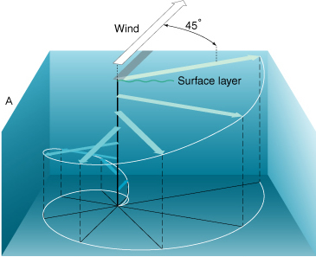

If Earth did not rotate, frictional coupling between moving air and the ocean surface would push a thin layer of water in the same direction as the wind.

This surface layer in turn would drag the layer beneath it, putting it into motion.

This interaction would propagate downward through successive ocean layers, like cards in a deck, **each moving forward at a slower speed than the layer above**.

However, because Earth rotates, the shallow layer of surface water set in motion by the wind is deflected to the right of the wind direction in the Northern Hemisphere and to the left of the wind direction in the Southern Hemisphere.

This deflection is **known as the Coriolis effect**

The Ekman spiral indicates that each moving layer is deflected to the right of the overlying layer's movement;

hence, the direction of water movement changes with increasing depth.

###### Direction of water movement

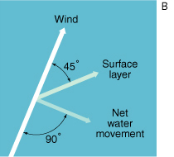

In an ideal case, a steady wind blowing across an ocean of unlimited depth and extent causes surface waters to move at an angle of 45 degrees to the right of the wind in the Northern Hemisphere (45 degrees to the left in the Southern Hemisphere).

In the Northern Hemisphere, the Ekman spiral predicts net water movement through a depth of about 100 to 150 m at 90 degrees to the wind direction .

**the resulting flow is at 90 degrees to the right of the wind direction.**

**In the Southern Hemisphere, the net water movement is 90 degrees to the *left*of the wind direction.**

This net transport of water due to coupling between wind and surface waters is known as **Ekman transport.**

**The stable pycnocline inhibits the transfer of kinetic energy to deeper waters,** helping to contain wind-driven currents to the mixed layer;

that is, the pycnocline acts as a permeable boundary for Ekman transport and surface currents.

Sloping of oceans

Ekman transport piles up surface water in some areas of the ocean and removes water from other areas, producing variations in the height of the sea surface, causing it to slope gradually.

###### Factors behind Ekman transport

1. Rotation of earth
2. Depth of water body
3. **Level of pycnocline**

## Garbage Patches

Ocean gyres circle large areas of stationary, calm water.

Debris drifts into these areas and, due to the region’s lack of movement, can accumulate for years.

These regions are called garbage patches.

The Indian Ocean, North Atlantic Ocean, and North Pacific Ocean all have significant garbage patches.

The garbage patch in the North Pacific Ocean is sometimes called the Pacific trash vortex or **the Great Pacific Garbage Patch.**

North pacific gyre🡪Turtle Gyre

## Gyres

Ocean gyres circle large areas of stationary, calm water.

Most of the world’s major gyres are subtropical gyres

These are nutrient-poor, because they have few concentrations of the organic chemicals that support producers, such as algae and plankton, in the ocean food web.

North Pacific 🡪Turtle gyre

South pacific🡪Heyerdahl gyre

North altantic 🡪Columbus gyre also Sargasso sea

South atlantic🡪Navigator gyre

Indian ocean🡪Ahmed Majid

The Sargasso Sea is a region in the gyre in the middle of the North Atlantic Ocean.

It is the only sea on Earth which has no coastline.

It is bounded on the

west by the Gulf Stream;

north, by the North Atlantic Current;

east, by the Canary Current; and

south, by the North Atlantic Equatorial Current.

This **system of ocean currents forms the North Atlantic Gyre.**

All the currents deposit the marine plants and refuse they carry into this sea

## Monsoon current

Mosoon Current, also **called Monsoon Drift,** surface current of the northern Indian Ocean.

Unlike **the Atlantic and Pacific, both of which have strong currents circulating clockwise north of the Equator,**

the northern Indian Ocean has surface currents that change with the seasonal monsoon.

**During the northeast monsoon (November–March), the Indian North Equatorial Current (or Northeast Monsoon Drift) flows southwest and west, crossing the Equator**.

Between this westerly current and the westerly current maintained south of the Equator by the southeast trade winds, a strong Equatorial Countercurrent flows east at about latitude 10° S.

The southwest monsoon sets in from April to October.

Joining with the southeast trades, which at this time cross the Equator and veer to the southwest, it reverses the flow of the current, pushing the Southwest Monsoon Drift eastward and sending branches north into the Arabian Sea and Bay of Bengal, as a major western boundary current with surface current velocities as high as 9 miles (14 km) per hour.

In summers

Summer Circulation – **North Equatorial Current Counter-Equatorial Current are Absent**

* due to the effects of the strong south-west monsoon and the absence of the north-east trades, a strong current flows from west to east, which completely *obliterates the north equatorial current*. Hence, there is ***no counter-equatorial current as well***.
* Thus, **the circulation of water in the northern part of the ocean is clockwise during summer seaso**n

# Climatology

## Layers of atmosphere

TROPOSHERE

* It is the atmospheric layer between the earth’s surface and an altitude of 8 km at the poles and 18 km at the equator.
* **The thickness is greater at the equator, because the heated air rises to greater heights.**
* **The troposphere ends with the Tropopause.**
* The temperature in this layer, as one goes upwards, falls at the rate of 5°C per kilometer, and reaches -45°C at the poles and -80°C over the equator at Tropopause (**greater fall in temperature above equator is because of the greater thickness of troposphere – 18 km**).
* **The fall in temperature is called ‘lapse rate’. 6.5C per 1 km as you go high**
* **The troposphere is marked by temperature inversion, turbulence and eddies.**
* It is also meteorologically the most significant zone in the entire atmosphere (Almost all the weather phenomena like rainfall, fog and hailstorm etc. are confined to this layer).
* **It is also called the convective region, since all convection stops at Tropopause.**
* The troposphere is the theatre for weather because all cyclones, anticyclones, storms and precipitation occur here, as all water vapours and solid particles lie within this.
* The troposphere is influenced by seasons and jet streams.

STRATOSPHERE

* It lies beyond troposphere, up to an altitude of 50 km from the earth’s surface.
* The temperature in this layer remains constant for some distance but **then rises to reach a level of 0°C at 50 km altitude.**
* **This rise is due to the presence of ozone** (harmful ultraviolet radiation is absorbed by ozone).
* This layer is **almost free from clouds and associated weather phenomenon,** making conditions most ideal for flying airplanes. So airplanes fly in lower stratosphere, sometimes in upper troposphere where weather is calm.
* Sometimes, **cirrus clouds are present at lower levels in this layer**.
* Ozone presence here

MESOSPHERE

* This is an intermediate layer beyond the ozone layer and continues upto an altitude of 80 km from the earth’s surface.
* **The temperature gradually falls to -100°C at 80 km altitude**.
* **Meteorites burn up in this layer on entering from the space.**

THERMOSPHERE

* In **thermosphere temperature rises very rapidly with increasing height**.
* **Ionosphere is a part of this layer**.
* It extends between 80-400 km.
* This layer **helps in radio transmission**.
* In fact, radio waves transmitted from the earth are reflected back to the earth by this layer.
* Person would **not feel warm because of the thermosphere’s extremely low pressure**.
* **The International Space Station and satellites orbit in this layer**.
* (Though temperature is high, the atmosphere is extremely rarified – gas molecules are spaced hundreds of kilometers apart. Hence a person or an object in this layer doesn’t feel the heat) **Aurora’s are observed in lower parts of this layer.**

IONOSPHERE

* This layer is located between 80 km and 400 km and is an **electrically charged layer.**
* This layer is characterized **by ionization of atoms.**
* Because of the electric charge, radio waves transmitted from the earth are reflected back to the earth by this layer.
* Temperature again **starts increasing with height because of radiation from the sun**.

EXOSPHERE

* This is the uppermost layer of the atmosphere extending beyond the ionosphere above a height of about 400 km.
* The air is extremely rarefied and **the temperature gradually increases through the layer**.
* Light gases **like helium and hydrogen float into the space from here**.
* Temperature gradually increases through the layer. (As it is exposed to direct sunlight)
* **This layer coincides with space.**

## ITCZ

As air rises near the equator and then flows poleward, it leaves an area of fewer air molecules at the equator.

This is a region of low pressure because there is a smaller mass of air left over the equator.

Air from the subtopics, north and south of the equator, flows in to fill the space, completing the **loop of Hadley Circulation.**

The area near the equator with low pressure and converging, rising winds is called the **Intertropical Convergence Zone (ITCZ).**

The Hadley Circulation doesn’t stay in the same place year-round, but varies with the seasons

Shifting of ITCZ

During December and January, the Southern Hemisphere is heated more strongly by the sun than the Northern Hemisphere, so the hottest air – the air that rises in **the ITCZ – is found a little south of the equator.**

**Winds from the Northern Hemisphere blow across the equator towards the ITCZ.**

During June and July,

the Northern Hemisphere is heated more strongly by the sun, so the ITCZ and its rising hot air lie a little north of the equator and

**winds blow from the Southern Hemisphere across the equator to reach the ITCZ in the Northern Hemisphere.**

**As the ITCZ changes location through the year, the winds and rains and the location of monsoon wet weather changes, too**.

During winter, air descends over tropical continents as the part of the Hadley Circulation that is outside of the ITCZ.

**Descending air causes high pressure, and makes clouds and rain uncommon**.

The dry conditions during winter can even lead to drought if they are too intense or persist for too long

**during Northern Hemisphere winter the ITCZ is south of the equator and monsoon rains fall in northern Australia**.

**During Northern Hemisphere summer, the ITCZ is north of the equator and monsoon rains fall in India and other parts of south Asia as winds blow north from the tropical ocean to the land, while northern Australia experiences very dry conditions as air descends**.

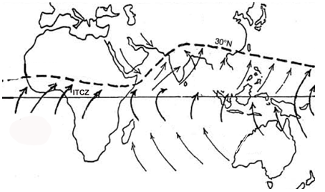

## Monsoon

**Southwest monsoon in general is called as Indian monsoon**

**Northeast monsoon is called as Retreating monsoon**.

South west monsoon have 2 branches

Arabian sea branch and

BOB branch

Himalayas effect on monsoon

the established view came to be that the Himalayas acted on the monsoon in two ways. The Tibetan plateau, heated up during summer and thereby established an atmospheric circulation that was conducive for the monsoon.

The vast mountain range also acted as a tall barrier, preventing cold, dry air in the northern latitudes from entering the subcontinent and subduing the warm, moisture-laden winds from the oceans that drive the monsoon.

Tibet effect

Can be seen in image above

## Trade winds

**Trade wind**, persistent [wind](https://www.britannica.com/science/wind) that blows westward and toward the [Equator](https://www.britannica.com/place/Equator) from the subtropical high-pressure belts toward the [intertropical convergence zone](https://www.britannica.com/science/intertropical-convergence-zone) (ITCZ).

**Direction**

Towards equator and from north east direction

North east trade

South east trade

It is stronger and more consistent over the oceans than over land and often produces **partly cloudy sky conditions**, **characterized by shallow cumulus clouds**, or

clear skies that make **trade-wind islands popular tourist resorts.**

**One of the reason of rainfall in doldrums**

## Westerlies

 S.W. to N.E. in the northern hemisphere

 N.W. to S.E in the southern hemisphere

**Help in formation of Temperate cyclones**

**Brings temperate cyclones to India**

In Europe

westerlies bring much precipitation in the western parts of the continents

velocity of the westerlies becomes so great that they are called

**roaring forties between the latitudes of 40°-50° S,**

**furious fifties at 50°S latitude and**

**shrieckng sixties at 60° S latitude.**

## Horse latitudes

Latitudes separating trade winds and westerlies

Calm weather conditions

**Anti cyclonic conditions**

These anticyclones are known **as ‘subtropical highs’ or subtropical anticy­clones**

**This is why hot and dry tropical deserts are found in the western parts of the continents within the latitudinal zones of 20°-30° in both the hemispheres (e.g. Sahara and Kalahari in Africa, Chile-Peru desert or Acatama in South America, Arabian and Thar deserts in Asia, deserts of S. W. USA, and Australian deserts).**

Temperature inversion conditions.

## Polar winds/Easterlies

**winds blow from polar high pressure to sub-polar low pressure cells.**

**These are called polar winds which are north-easterly in the northern hemisphere and south-easterly in the south­ern hemisphere**

## Jet Streams

Latitudinal location:

**b/w 30N and 60N(sub polar jet streams)**

The weaker subtropical jet stream is located closer to 30°N(sub tropical jet streams)

Atmospheric location

At tropopause

**i.e upper troposphere and lower stratospheres**

**Jets are very cold**

**Rotation of earth:**

###### Greater at equator

**As latitude increases and the speed of the earth's rotation decreases, Coriolis effect increases**

Sun:

They follow the Sun

**Move to north with warm weather**

**Move to south with cold weather**

Winter:

**Stronger jet streams as due to difference in temp. of cold air mass and hot air mass increases**

Direction

**West to east (both sub polar and sub tropical jet streams)**

African Jet west to east help to bring monsoon over Africa

**Tropical easterly Jet(east to west)**

**Helps in kink starting south west Monsoon in India(summer monsioon)**

**Consequence of heating of Tibet plateau**

**Tibetan plateau is responsible for south-west monsoons**

**during the month of June is an important feature of Indian summer monsoon**

Consequences

 it has the ability to push weather patterns around the world

their position and strength of the jet stream then helps meteorologists forecast future weather events.

Shifting

**Due to global temperatures**

**Due to daily temperature**

The world’s jet streams are also impacted by [El Nino and La Nina](https://www.thoughtco.com/el-nino-and-la-nina-overview-1434943).

During [El Nino](https://www.thoughtco.com/what-is-el-nino-3444119) for example, the polar jet stream moves farther south and vice versa

## Shifting of wind Belts

the position of all the pressure belts except the polar high pressure belts changes with the northward and southward migration of the sun.

At the time of **summer solstice** the sun is vertical over the **tropic of Cancer (June 21)** and therefore all the pressure belts except the northern polar high pressure belt **shift north­ward**

The sun becomes vertical over the equator at the time of **autumnal equinox (23 September)** and hence all the pressure belts which shifted to the north **occupy their normal positions**

sun which becomes verti­cal over the **tropic of Capricorn at the time of winter solstice** (23 December) and hence the **pressure and wind belts shift southward** except the **southern polar high pressure belt.**

Sun is over equator in summer equinox (21 March) and hence all the pressure and wind belts occupy their normal positions

**there is shifting in the positions of the pressure and wind belts due to seasonal changes of position of the earth in relation to the sun**.

## Effects of shifting of wind belts

**The Mediterranean climatic regions** are found in the western parts of the continents within the latitu­dinal zone of 30°-45° in both the hemispheres.

**Reason**

The subtropical high pressure belts extending between 30°- 35° latitudes are characterized by dry trade winds during summer season because mostly they come from over the land

**This belt extends upto 40° latitudes in the northern hemisphere at the time of summer solstice and in the southern hemisphere at the time of winter solstice.**

**Ie why the western parts of the continents within the zone of 30°-40° latitudes do not receive rainfall during summer season**

the subtropical belt shifts towards the equator at the time of winter solstice in the northern hemisphere and at the time of summer solstice in the southern hemisphere,

consequently, the zone between 30°-40° latitude is characterized by westerlies which give much precipitation during winter season because they come from over the oceans.

This is why the Mediterranean regions are characterized by dry summers and wet winters and a typical Mediterranean type of climate is produced.

**Monsoons**

The seasonal changes in the **Hadley Circulation create the world’s monsoons**

**Monsoon climate is the result of the shifting of pressure and wind belts.**

Due to northward migration of the sun in the northern hemisphere at the time of summer solstice **the north intertropical convergence (NITC) is extended upto 30°N latitude over Indian subcontinent,** south-east Asia and parts of Africa. Thus, the equatorial westerlies are also extended over the aforesaid regions.

These equatorial westerlies, in fact, **become the south-west or summer monsoons.**

The NITC is withdrawn from over the Indian subcon­tinent and south-east Asia because of southward shift­ing of pressure and wind belts due to southward migra­tion of the sun at the time of winter solstice**.**

Thus, north-east trades are re-established over the aforesaid areas. These north-east trades, in fact, are north-east or winter monsoons. Since they come from over the lands, and hence they are dry

## Doldrums

Between 5degree north /south of equator

Calm weather conditions

formation of **cumulonimbus clouds and copious rain­fall daily**

the belt of doldrum shifts northward during summer solstice (when the sun is vertical

On an average, there is westerly air circulation (form west to east) in the doldrums or say in the intertropical convergence.

These westerly winds have been **called by Flohn as equatorial westerlies**

**south-western monsoons are, infact, equatorial west­erlies** because these winds are extended **upto 30-35°N latitudes over Indian subcontinent due to northward shifting of NITC at the time of summer solstice**

## Temperature Inversion

Hot air above cold air situation

**Normally temp. decrease as we go up in troposphere**

**But in this scenario it increases**

**Anti cyclonic conditions results in temp. inversion**

Consequences:

Less rainfall due to low cloud formation

Presence of More dust and pollution.

Low visibility Because air near the base of an inversion tends to be cool, [fog](https://www.britannica.com/science/fog) is frequently present there.

## Mango showers

In India, the mango showers occurs as the result of thunderstorm development over the Bay of Bengal.

Pre-Monsoon Rains

They are also known as **'Kalbaishakhi' in Bengal**,

as **Bordoisila in Assam** and

**as Cherry Blossom shower or Coffee Shower in Kerala**

## Polar vortex

The polar vortex is a winter phenomena.

It develops as the sun sets over the polar region and temperatures cool .

.

Features

The stratospheric polar vortex is a large-scale region of air that is contained by a strong west-to-east jet stream that circles the polar region.

This jet stream is usually referred **to as the polar night jet**

The polar vortex extends from the tropopause (the dividing line between the stratosphere and troposphere) **through the stratosphere and into the mesosphere (above 50 km).**

In both hemispheres

Polar vortex in Southern hemisphere is stronger than northern part

Can rise up to stratosphere and into mesosphere

CFCs are destroyed in the upper stratosphere

In southern hemisphere

Prevails over large area and for longer duration

During winter, temperatures in the vortex usually drop **and polar stratospheric clouds form**.

C**old air trapped within the Antarctic polar vortex contributes to the development of nacreous clouds (a type of polar stratospheric cloud [PSC] made up of water and**[**nitric acid**](https://www.britannica.com/science/nitric-acid))

PSCs convert less-reactive [chlorine](https://www.britannica.com/science/chlorine)-containing molecules to more-reactive forms, such as molecular chlorine (Cl2), which contribute to the [ozone hole](https://www.britannica.com/science/ozone-depletion).

PSC can be natural or related to CH4 concentration in atmosphere.

Chemical reactions on the surfaces of **these cloud particles releases chlorine that originated from CFCs into forms that can rapidly destroy ozone**.

**Consequence**

**Depletion on Ozone**

Ozone units: **Dabson unit**

## Rosby waves

**Rossby wave**, in [meteorology](https://www.britannica.com/science/meteorology), large horizontal atmospheric undulation that is associated with the polar-front [jet stream](https://www.britannica.com/science/jet-stream) and separates cold polar air from warm tropical air.

* The meandering jet streams are called **Rossby Waves.**
* **Rossby waves are natural phenomenon in the atmosphere and oceans due to rotation of earth.**

Rossby waves are formed when polar air moves toward the Equator while tropical air is moving poleward

 The existence of these waves explains the low-pressure cells ([cyclones](https://www.britannica.com/science/cyclone-meteorology)) and high-pressure cells ([anticyclones](https://www.britannica.com/science/anticyclone)) that are important in producing the [weather](https://www.britannica.com/science/weather) of the middle and higher latitudes.

# Forests

###### TYPES OF FORESTS

###### Tropical Rainforest

Location: The tropical rainforests contain the greatest diversity of species of all biomes on earth. They are found around the equator, between 23.5 degrees N latitude and 23.5 degrees S latitude.

Climate: Temperatures in tropical rainforests remain between 68 and 77 degrees Fahrenheit all year long. **Winter is absent in these forests**.

Most tropical rainforests receive 100 inches of rain per year.

Soil: Because the temperature is warm and the air moist, **decomposition happens at a very fast rate in tropical rainforests.**

High levels of rainfall often lead to leaching of nutrients from the soil, creating soils that are nutrient poor.

Plants: Trees in the tropical rainforests grow between 82 and 115 feet tall and are **typically broad-leafed trees**.

Trees are 25-35 m tall, **with buttressed trunks and shallow roots**, mostly evergreen, with large dark green leaves.

Plants such as orchids, bromeliads, vines (lianas), ferns, mosses, and palms are present in tropical forests

.

Animals: Dense growing trees create a thick canopy layer in tropical rainforests that keep the sun from penetrating to the lower layers of the forest.

This means that most animals that live here must be adapted to living in the trees. A variety of birds, bats, monkeys, snakes and other animals can be found in tropical rainforests.

**Threats: The biggest threat to tropical rainforests is unsustainable forestry practices. Other threats** include road construction, clearing land for agriculture and other development activities and climate change.

###### Temperate Deciduous Forest

Location: Eastern United States and Canada, Western Europe and parts of Russia, China and Japan.

Climate: **There are four distinct seasons in temperate deciduous forests and precipitation falls throughout the year, as rain in the spring, summer and fall and snow in the winter.**

Moderate climate and a growing season of 140-200 days during 4-6 frost-free months distinguish temperate forests

Temperate deciduous forests receive 30-60 inches of rain per year.

Soil: The soil in these forests is very fertile.

Plants: The forest floor in temperate deciduous forests supports mosses, ferns and wildflowers and the understory supports a variety of shrubs and ferns.

Trees are distinguished by broad leaves that are lost annually and include such species **as oak, hickory, beech, hemlock, maple, basswood, cottonwood, elm, willow, and spring-flowering herbs.**

Animals: Animals living in temperate deciduous forests must be adapted to cold winters. Common species found in temperate deciduous forests include, red fox, hawks, woodpecker and cardinals.

Threats: **Acid rain caused by industrial and vehicular emissions poses the biggest threat to temperate deciduous forests**. Over time, acid rain damages tree leaves, causes trees to produce fewer and smaller seeds and reduces resistance to disease. Other threats include unsustainable forestry, strip mining and the spread of invasive, non-native species that compete for space and food. Climate change is also a threat.

###### Temperate Coniferous Forest

Location: Temperate coniferous forests are typically found in coastal areas with mild winters and heavy rainfall or in in-land mountainous areas with mild climates.

Examples of where these forests are found are Pacific Northwestern United States and Canada, southwestern South America, Southern Japan, New Zealand and small parts of northwestern Europe (Ireland, Scotland, Iceland and Norway).

Climate: Temperate climate with temperature that fluctuates little throughout the year. High levels of precipitation (50-200 inches per year) cause **a moist climate and a long growing season.**

Soil: **Soils are generally rich with a thick layer of decaying material.**

Plants: **Evergreen conifers dominate these forests.**

Due to the high levels of precipitation and moderate temperatures, there is a long growing season, resulting in trees that grow very tall.

Dominant tree species found **in temperate coniferous forests include** **cedar, cypress, Douglas fir, pine, spruce and redwood**.

There are some deciduous trees such as maple, and mosses and ferns are common.

Animals: Examples of animals that live in temperate coniferous forests are, deer, marmot, elk, black bear, salmon, spotted owl, marbled murrelet

**Threats: Unsustainable forestry, road construction and other development related activities are the** biggest threat to temperate deciduous forests.

###### Boreal (taiga) Forest

 taiga, represent the largest terrestial biome.

**Location: This is the northern most forest type and is found between 50 and 60 degrees N latitude. Boreal forests are found in Canada, northern Asia, Siberia and Scandinavia (Denmark, Norway, Sweden, Finland).**

About two-thirds of the world's boreal forests are found in Scandinavia.

Climate: **Boreal forests are characterized by long winters and short summers.** Most precipitation is in **the form of snow and these forests receive between 15 and 40 inches of precipitation per year.**

Soil: Because of cold temperatures, decomposition takes a long time, resulting in thin soil.

Plants: **Trees are mostly evergreen and include species such as spruce, fir and pine.**

cold-tolerant evergreen conifers with needle-like leaves, such as pine, fir, and spruce.

Animals: Animals found here must be adapted to long, cold winters and usually have thick fur. Deer, moose, elk, caribou, snowshoe hare, wolves, grizzly bears, lynxes and wolverines are some examples.

# Disaster Management

Disaster management means a continuous and integrated process of planning organizing and coordinating and implementing procedures which are important for :

Prevention of disaster

Mitigation or risk reduction of disaster

Capacity building

Preparedness to deal with any disaster

Assessing the severity or magnitude of disaster

Evacuation, rescue or relief

Rehabilitation and reconstruction

###### Basic unit of DMA 2005 is District level plans

###### National disaster management policy 2016

* National Disaster Management Plan based on the four priority themes of the Sendai Framework namely:
* understanding disaster risk,
* improving disaster risk governance,
* investing in disaster risk reduction (through structural and non-structural measures) and
* disaster preparedness, early warning and building back better in the aftermath of a disaster.
* NDMP spells out roles and responsibilities of all levels of Government right up to Panchayat and Urban Local Body level in a matrix format

###### National authority for Disaster management

9 memebers including chairman

PM chairman of NADM

Pm can nominate one of members a vice chairman

PM will preside over meeting of NDMA

Functions:

Approve national plan

National policies and guidelines to be followed by SDMA

Provision of Funds for policies

Guidelines for functioning of National institute for disaster management

###### Prepare annual report for parliament

###### National executive committee

Secretary to GOI act as Chairperson

Shall assist NDMA for implementing policies

Prepare **national plan** to be approved by NDMA ;reviewed and updated annually

Technical assistance to SDMA

Prepare guidelines for DM

National plan

###### National disaster response force

###### State disaster response force

###### National institute for Disaster management

National disaster response fund

Amount allocated to it after approval form parliament

**Amount given by any person or institution for purpose of DM**

Used to meet expenses for emergency response

###### National disaster mitigation fund

**state disaster mitigation fund**

**district disaster mitigation fund**

**state disaster response fund**

**District disaster response fund**

###### State disaster management authority

CM chairperson and other members not exceeding 9

Vice chairman of SDMA

State DM policy

State plan using guidelines of national plan

Implementing stae plan

###### Prepare annual report for state legislature

###### State executive committee

Chief secretary stae govt. chairperson

Implement national plan and national plan

Advice to district authorities

Prepare SDMPlan

State plan

###### District disaster management authority

Chairperson DC

Elected representative of local authority co-chairman

Appoint chief executive officer of district authority

Preprare DM plan and district response plan

Identify vulnerable areas in district

Guidelines for District DM plans

Encourage involvement of NGO’s

DM plan for district

Response plan to Disaster

Can give direction to any district or local authority for release of funds and resources in case odf disaster.

Establish emergency communication

**Establish Local authorities**

Ensure it’s officers are trained

Resources are maintained

Carry out rehabilitation and response activites accd. To Dplan and State Plan

Only High court and SC have jurisdiction for disputes arising due to actions taken by NDMA SDMA DDMA

# Test added data

Koppen gieger classification

Mega diverse countries

**17 countries;**

No European country;

**Containing 2/3 of all tropical rain forest;corals;**

Continental shelfs

are wider near river mouths

narrow where there are high mountains example andes mountain makes south American pacific shelf narrow

**oceanic crust Crust is made up of basalt,gabbro**

**continental crust made of less dense rocks not granite**

Canyons

Canyons or gorge are found in semi arid zones

**Result from weathering of rivers**

**Wider at top and narrow at bottom**

###### Formed on sedimentary rocks

Gorge

**Width same as top as it is in bottom**

**Canyon is a variant of gorge**

**Formed in hard rock**

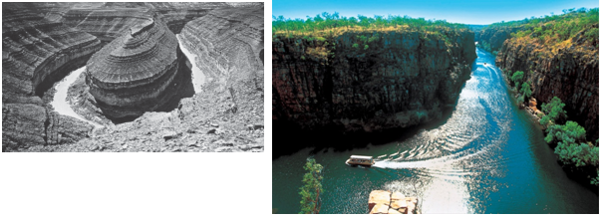

Dobson unit

Unit of ozone

**Highest in mid latitudes and canade and Siberia 360 db**

Global average is 300 db

Ozone hole when it is <200db

Tornadoes

Corriollis force no effect on tornadoes

Red soils

**Made from weathering of Metamorphic rocks**

**acidic**

Saline soils

High ph value highly basic

Not fit for agriculture

Soil erosion

Ssplash🡪sheet🡪rill🡪gulley

Soil creep:

Slow gradual movement of ROCK AND soil on the slope

Angular street lighs

Angular stones

Solifluction

Water saturated soil slides over permafrost due to gravity

Artesian basin

It is a land where ground water comes out as soon as you bore a well due to high pressure inside

Great artesian basin Australia main source of water in Australia.

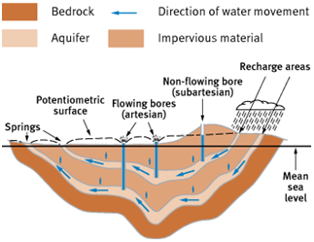

Glaciel land forms and karst landforms

??

Karst topography

It is formed due to dissolution of soluble rocks limestone and gypsum in underground water and rain water

Underground drainage is feature of this topography

System of sink holes and caves

Water streams disappear underground

Water seeps underground through sink holes on surface

Usually barren, no vegetation

Formation of stalactites(ceiling spikes) and stalagmites(floor spikes)

Magnetic declination

angle in north pole and magnetic north pole

it is variable

Equator

Seasons are insignificant there no concept of 4 seasons

Savanna

Tropical grasslands

In Australia ,Africa,India,Nepal, and America

Temperate grasslands

Pampas inn SAmerica in south eastern part

Prairies in USA

Steppes in australia

Veldts south africa

Tropical rain forest in south America

**Selvas in northern parts**

Grasslands

Develop where rainfall is not enough for development of forests

Tropical grasslands grow where temp. are high and seasonal rainfall

Cereals

Rice wheat are type of grasses

Wheat is most important in world in terms of consumption.

Organic fertilizer

Guano

From bats and bird shit

In south American islands

High in all NPK

South by organic farmers

Bio ethanol

Under national policy target is 20% ethanol blending by 2017

First generation biofuels are derived from sugar,starch,animal fats etc

Second generation biofuels are derived from crops and residue are also called as advanced biofuels

Rivers

**Karewas:small glaciel plateau’s in jhellum or Kashmir valley**

Kali Sindh in rajasthan not lost yet

Volga river is longest river of Europe.national river of Russia

But not a industrial hub

Keil river canal is in Germany most prominent canal in world

River Rhine-ruhr is largest metropolitan in germany

Busiest inland waterway in world is **St lawrance in North America** connection canada’s qubec and detroit

Connecticut valley is also industrial towns

Orange siiver flows in south afrinca

Chao pherya largest river in Thailand

Rift valley rivers

Tanganyika lake in west of east African rift valley

Lake Baikal largest fresh water lake

Lake Malawi in east African rift

Damodar and Narmada flows through river valleys or rift valleys

Straits

Strait of dover:England and france

Magellan channel: atlantic and pacific oceans

Boundaries

Maginot line 🡪france germany

17 parallel 🡪 North and south Vietnam

38 parallel🡪Noth and south Korea

49 parallel🡪Usa and Canada

South African plateau is opposite of indian plateau

i.e high on eastern side

also in south

North America

Applacian mountains run north to south near new York on eastern margin

East to west

Applacian mountains🡪canadian shiled and great lakes🡪great plains🡪western cordilleras(running north to south on western side of north america)

USA largest producer of natural gas and 2nd largest oil

USA has 40% of coal reserves of world

Busiest inland waterway in world is St lawrance in North America connection canada’s qubec and detroit

South America

Argentina capital buenes aires **paris of south America;was involved in Falkland war with britain**

Europe

alps run east to west

Brazil

Once largest exporter of Rubber but not now due to attack by a disease mycrocylus ullai

Kaladan multi modal project

Myanmar and Mizoram

Dead sea or salt sea

Israel and Jordan only

Isthmus:

It is narrow strip of land separating water bodies

Isthamus of panama

Patagonian desert

In argentina

Desert as it lies in rain shadow of andes

And arid sue to Falkland cold water current

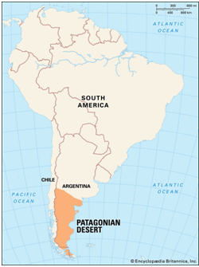

North sea

More saline than atlantic

Due to north atlantic drift

High saline less freezing

Black sea

Bosphorous strait ,sea of marmara and dardanalles strait

Ukraine not in EU but only in NATO

Lapis lazuli route:

Signed in 2017 in Turkmenistan

Start in Afghanistan herat and in Turkmenistan and crosses caspian sea and heads to baku in azerbaijan; Georgia capital tablisi; poti and batomi port at black sea and to turkey and into Europe

Nigeria and south sudan also conflict zones

Do not include iran

Red sea

Most saline

Due to less fresh water

High evaporation

Low connection with arabian sea which has less salinity as compared to red sea

Tropic of cancer

Passes via Africa in Algeria,mali,Egypt Libya niger,mexico,Bahamas,china Bangladesh india Myanmar,oman Saudi arabia

Arabian sea and BOB

Arabian sea more saline than BOB

Climate change effect more in Indian ocean due to BOB and ASea are covered from three side from land in northern hemisphere

So large land ,more heating ,more strong land breeze cause upwelling of water

So more rise in level

Block mountains

Large block of crust are broken and displaced vertically

Uplifted blocks are called hoarts

Lowered blocks are Grabben

Rift valley Africa

Rhine valley

Vosges in Europe are example

Prime meridian

Passes via france, England, spain,Algeria,mali,mali,ghana,antartica

Latitude calculation

Using Sun at noon

North star

Gravitational anomaly

It is difference in actual value and calculated value of gravity at a place

It is due to underlying rock density

Solar system

Red shift big bang expansion theory

13 billion years ago

Largest solar system is Jupiter

Ganymede of jupiter is largest satellite in solar system

Least dense is Saturn

Most dense mercury

Messenger aircraft to mercury

Solar and lunar eclipse

Lunar eclipse only at night when no moon not on new moon night

Solar eclipse shorter duration than lunar eclise

Season on earth due to axis tilt

Daya night due to rotaiton

Diamond ring and beilly beads occur during solar eclipse

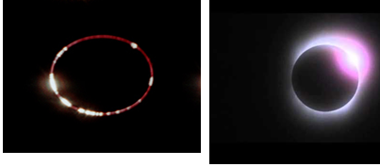

Tidal locking

Occur in pair of two bodies when they rotate in sync with each other

**Tidal locking** is the name given to the situation when an object's orbital period matches its rotational period.

Only one side of moon is seen always as

Amount of time taken by it to rotate it around axis is same as time taken by it to revolve around it i.e 27 days

CBD

Adopted on earth summit in Rio in 1992,enter into force 1993

India signed it in 1994

Law🡪Indian biodiversity act 2002,National biodiversity authority

IPCC

Inter governmental committee under UN

Proides objective scientific iew on climate change

Do not holds it’s own research

Global environment facility

India is not founding member

Act as finance for Unfcc and CBD

Est. in 1991

Carbon sequestration

Process of capturing and long term storage of atmospheric co2

Can be done via

Increasing wetlands

Increase area under bogs and wetlands

Installing carbon scrubbers in factories

Biomass

Biomass is renewable source of energy

Can be used in internal combustion engine

National parks

Human settle ment is allowed

Acts india

Wildlife protection act🡪1972

Forest conservation act🡪1980

Ganga action Plan🡪1986

Environment protection act🡪1986

Biosphere reserves

T.nadu and MP has 3(Maximum)

Assam has 2

Simplipal in Odisha is on eastern ghats

Panna B reserve on Ken river

Kanchendzonaga biosphere reserve

Roots

Succelants roots are not deep

Hydrophytes

In aquatic environment

Roots can be fully submerge or partially

Spongy pore in leaves and stems to help in gas exchange

Tropophytes shed leaves in extreme climates

Shale India

This process converts kerogen in oil shale into shale oil by pyrolysis, hydrogenation, or thermal dissolution

Not extracted by cracking

cracking is the process whereby complex organic molecules such as kerogens or long-chain hydrocarbons are broken down into simpler molecules such as light hydrocarbons, by the breaking of carbon-carbon bonds in the precursors

Octane ratings of petrol are 87, 88, 89, 90, 91, 93 and 97, which symbolize purity and refinement in increasing order

Speed petrol is high octane rating

Exploration in india started at Jambusar in Bharuch in Gujarat

Canadian shield

**Canadian Shield**, one of the world's largest geologic continental shields, centred on Hudson Bay and extending for 8 million square km (3 million square miles) over eastern, central, and northwestern Canada from the Great Lakes to the Canadian Arctic and into Greenland

Atmosphere

Earth emits long wave radiation

Pressure decreases as we move up🡪 adiabatic lapse rate

Temperature decreases with height

Learn about other layers and temp features

Stratosphere🡪ozone is in this layer;temp rises as we go up(due to ozone);free from clouds

Adiabatic rate🡪dry and wet

Lapse rate

Columnos clouds are puffy clouds

Astrostratus are mid altitude clouds,grey blue

Air masses uniform temp and presuure and moisture

Heat wave according to IMD

Atleast 40 degree celcius temp

Max temp is 45 or more

British type climate is found in south hemisphere in tip og south America and newzeland

La nina

Coriollis force very strong during this time,

El nino liitle effect on coriollis

Convectional rainfall

Associated with cumulonimbus clouds,thunder storms

When hot ari rises and form clouds and rain

In summers

In Irish summers

Happen every day in equator

Mediterranean climate

In san fransisco, rome and perth

Monsoon front

Where south west monsoon meets north east trades and it rains

Currents

Labrador and gulf stream meat at newfoundland Richest fishing grounds in world

Earthquakes

Himalayan🡪continental plate collision

Fukushima🡪convergent plate tectonics

Koyna🡪reservoir induces

Bhuj🡪intra plate

Due to earth quakes more tsunamis in pacific oceans

P- waves faster waves

L waves are surface waves, cause more destruction

S wave shadow zone larger than P-wave

Deep earth quake more destructive than shallow

90% earthquakes are shallow most common in mid oceanic regions

Continental drift theory weak points

Only talk about continents not about oceans

Tropical cyclones:

Not formed near equator as corroilis force is zero

Volcanoes

lava is acidic helps in formation of islands

basaltic lava help in seafloor spreading and no island formation

magma comes from asthenosphere

Oceanic landforms

Guyots are seamounts with flat tops found in pacific oceans extensively

Seamounts are spikes mountains in oceans but do not come out of surface

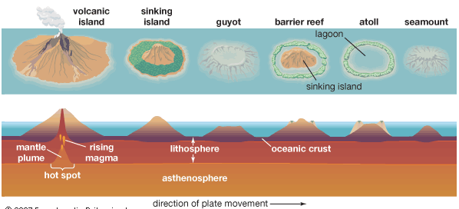

Beach formation

Finer particles close to sea

Coarser material at top of beach

Backwash creates finer material in shallow waters

Strong swash or constructive wave pilles coarser material away from sea at top on beach

Transhumance

Movement of people in winters towards low areas and summers into highlands

Practiced between both altitudes and latitudes

Tribes

Masai🡪pastoralists pf Tanzania and keyneya

Hausa🡪settled community

Bindibu🡪Australian, more older than Australia aboriginals

Iniuts 🡪live in Canada ,Greenland ,Alaska

Orang asli🡪live in malay peninsula oldest in that area

Moderen man

In holocen era

the current **epoch** is the Holocene **Epoch** of the Quaternary **Period**